ONLINE BANKIG SERVICES AND MOBILE BANKING APPLICATIONS

In the United States, online banking services and mobile banking services provided by financial institutions typically include a comprehensive suite of features designed to offer customers convenience, security, and control over their finances.

**1. Account Management**

* **Viewing Account Information**: Access real-time balances and transaction histories for checking, savings, and other types of accounts.
* **Statements and Documents**: View and download monthly account statements, tax documents, and other important notices.
* **Account Alerts**: Set up and receive notifications for account activities such as low balances, large transactions, and due dates for bills.

**2. Funds Transfer**

* **Internal Transfers**: Move money between different accounts within the same bank.
* **External Transfers**: Transfer funds to accounts at other banks through ACH (Automated Clearing House) or wire transfers.
* **Zelle and Other P2P Services**: Send and receive money quickly using services like Zelle, Venmo, or PayPal.

**3. Bill Payments**

* **One-Time Payments**: Pay utility bills, credit card bills, and other expenses with a single transaction.
* **Recurring Payments**: Schedule automatic payments for recurring bills such as rent, mortgage, and subscriptions.
* **e-Bills**: Receive and view electronic versions of your bills directly within the online banking platform.

**4. Mobile Banking**

* **Mobile Apps**: Banks offer dedicated mobile applications for both iOS and Android devices with functionality similar to their online banking portals.
* **Mobile Check Deposit**: Deposit checks by taking a photo with your mobile device.
* **Mobile Wallets**: Link your bank account to mobile payment services like Apple Pay, Google Pay, and Samsung Pay.

**5. Loan Services**

* **Loan Applications**: Apply for personal loans, mortgages, auto loans, and other types of credit online.
* **Loan Management**: View loan balances, payment schedules, and make payments.
* **Pre-Approval and Rate Checks**: Check for loan pre-approvals and current interest rates without impacting credit scores.

**6. Investment Services**

* **Brokerage Accounts**: Access and manage investment accounts, including trading stocks, bonds, and mutual funds.
* **Retirement Accounts**: Manage IRAs, 401(k)s, and other retirement accounts.
* **Financial Planning Tools**: Use tools for retirement planning, college savings, and other financial goals.

**7. Customer Support**

* **Online Chat and Messaging**: Get real-time assistance through live chat or secure messaging.
* **Virtual Assistants**: Use AI-powered virtual assistants for quick answers to common banking questions.
* **Appointment Scheduling**: Book appointments with bankers or financial advisors online.

**8. Security Features**

* **Two-Factor Authentication (2FA)**: Enhance security by requiring a second form of verification.
* **Account Monitoring**: Set up alerts for unusual account activities and monitor for potential fraud.
* **Secure Messaging**: Communicate securely with bank representatives through encrypted messaging systems.

**9. Personal Finance Management**

* **Budgeting Tools**: Track spending, create budgets, and analyze financial habits.
* **Expense Categorization**: Automatically categorize transactions for easier tracking and analysis.
* **Goal Setting**: Set and track financial goals like saving for a vacation, emergency fund, or down payment.

**10. Card Services**

* **Card Management**: Activate new cards, request replacements, and report lost or stolen cards.
* **Card Controls**: Set spending limits, freeze/unfreeze cards, and set up transaction alerts.
* **Rewards and Benefits**: Manage and redeem rewards points, cash back, and other card benefits.

**Regulatory and Security Standards**

* **Regulations Compliance**: Adhere to regulations such as the Electronic Fund Transfer Act (EFTA), the Gramm-Leach-Bliley Act (GLBA), and the Federal Financial Institutions Examination Council (FFIEC) guidelines.
* **Data Protection**: Implement robust data protection measures to safeguard customer information.

Online banking in the US is designed to provide a secure, user-friendly experience, with many banks continuously updating their features to keep up with technological advancements and customer expectations.

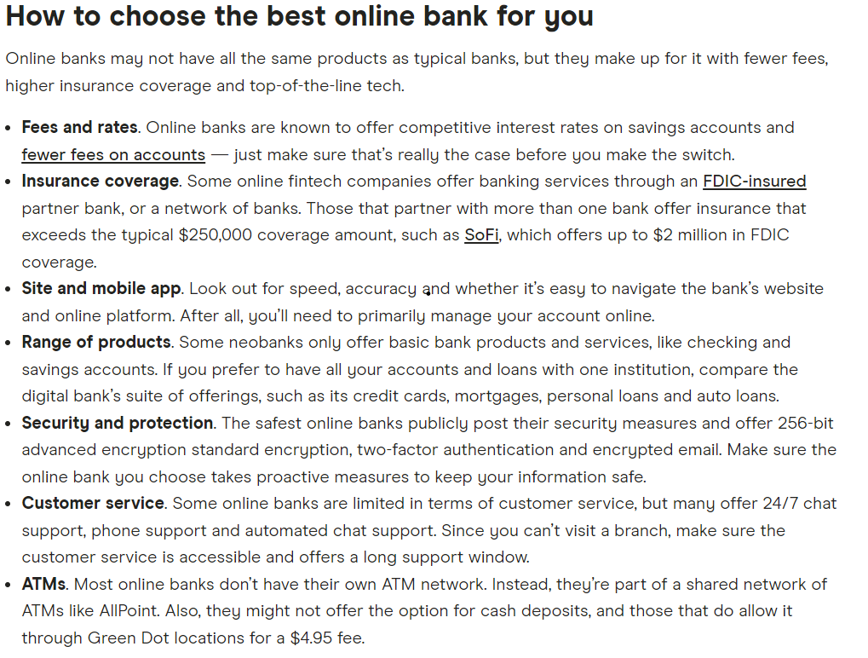

TOP 5 ONLINE BANKS

**1. Ally Bank**

* **Key Features**:
  + High-interest savings accounts.
  + No monthly maintenance fees.
  + Comprehensive mobile and online banking tools.
  + 24/7 customer service.
  + Savings Account APY: 4.00%
  + Checking Account APY: 0.25%
  + Monthly Fees: None
  + Minimum Balance: None
  + Customer Service Rating: 4.5/5

**2. Chime**

* **Key Features**:
  + No monthly fees or minimum balance requirements.
  + Early direct deposit.
  + Automatic savings features.
  + Extensive fee-free ATM network.
* **Standout Service**: Chime is known for its fee-free structure and features that help users save automatically.
* Savings Account APY: 2.00%
* Checking Account APY: None
* Monthly Fees: None
* Minimum Balance: None
* ATM Network: 60,000+ fee-free ATMs
* Customer Service Rating: 4.3/5

**3. Discover Bank**

* **Key Features**:
  + Competitive interest rates on savings and CDs.
  + No fees on checking and savings accounts.
  + Cashback rewards on debit card purchases.
  + 24/7 customer service.
* **Standout Service**: Discover offers a unique cashback feature on its checking account, which is rare among banks.
* **Savings Account APY**: 4.00%
* **Checking Account Cashback**: 1% on up to $3,000 monthly debit card purchases
* **Monthly Fees**: None
* **Minimum Balance**: None
* **Customer Service Rating**: 4.6/5

**4. Axos Bank**

* **Key Features**:
  + High-yield savings and checking accounts.
  + No monthly fees or minimum balance requirements.
  + Unlimited ATM fee reimbursements.
  + Advanced online and mobile banking tools.
* **Standout Service**: Axos is noted for its high-yield accounts and unlimited ATM fee reimbursements.
* • **Savings Account APY**: Up to 4.11% (tiered)
* • **Checking Account APY**: Up to 1.25% (tiered)
* • **Monthly Fees**: None
* • **Minimum Balance**: None
* • **ATM Network**: Unlimited ATM fee reimbursements
* • **Customer Service Rating**: 4.2/5

**5. Varo Bank**

* **Key Features**:
  + No monthly fees or minimum balance requirements.
  + High-interest savings accounts.
  + Early direct deposit.
  + Fee-free ATM network.
* **Standout Service**: Varo provides competitive interest rates and a completely fee-free experience.
* • **Savings Account APY**: Up to 5.00% (on balances up to $5,000)
* • **Checking Account APY**: None
* • **Monthly Fees**: None
* • **Minimum Balance**: None
* • **ATM Network**: 55,000+ fee-free ATMs
* • **Customer Service Rating**: 4.3/5

VOICE BANKING SERVICES

Voice banking services in the US provide an additional layer of convenience by allowing customers to perform banking tasks through voice commands, either via a mobile app, smart speaker, or a phone call. These services are often integrated with voice assistants like Amazon Alexa, Google Assistant, or proprietary voice recognition systems

**Examples of Voice Banking Services**

1. **Capital One Skill for Amazon Alexa**
   * **Key Features**: Check balances, review recent transactions, pay bills, and manage credit cards using voice commands via Alexa-enabled devices.
   * **Example Command**: "Alexa, ask Capital One for my checking account balance."
2. **Bank of America’s Erica**
   * **Key Features**: Erica is an AI-driven virtual assistant available within the Bank of America mobile app, which can handle tasks like checking balances, finding transactions, and providing financial advice.
   * **Example Command**: "Erica, show my spending for this month."
3. **Wells Fargo with Google Assistant**
   * **Key Features**: Perform banking transactions such as checking balances and reviewing recent transactions using Google Assistant on smart speakers or smartphones.
   * **Example Command**: "Hey Google, talk to Wells Fargo about my recent transactions."
4. **U.S. Bank Smart Assistant**
   * **Key Features**: Available in the U.S. Bank mobile app, this voice assistant can help with balance inquiries, transaction history, bill payments, and more.
   * **Example Command**: "What is my checking account balance?"

**How Voice Banking Services Work**

1. **Voice Command Input**
   * Users interact with the banking service through voice commands using their smart speaker, smartphone, or directly through a banking app.
   * Commands are processed using Natural Language Processing (NLP) to understand the user’s request.
2. **Authentication**
   * Initial setup may require linking bank accounts to the voice assistant with secure login credentials.
   * Voice authentication and additional PIN/password may be used for security.
3. **Processing and Response**
   * The voice assistant communicates with the bank’s servers via APIs to retrieve the requested information or perform transactions.
   * The response is converted back into speech and delivered to the user through the device.
4. **Security Measures**
   * Voice banking incorporates multiple layers of security, including encryption, voice recognition, and multi-factor authentication, to protect user data and transactions.

**Benefits of Voice Banking**

* **Convenience**: Hands-free banking allows users to perform tasks while multitasking.
* **Accessibility**: Enhances accessibility for visually impaired users and those who prefer voice interaction over typing.
* **Efficiency**: Quick and easy access to account information and transactions.

**Considerations**

* **Security**: Ensuring robust security measures to prevent unauthorized access.
* **Privacy**: Users need to be aware of their surroundings to avoid disclosing sensitive information aloud.

Voice banking services are continuously evolving, with banks adding more functionalities and improving the user experience through advancements in AI and voice recognition technologies.